课 题 | Unit 4 Do you like pears?
教学目标 | 掌握认读新词：apple strawberry grapes . 学习歌谣
教学重点 | 掌握认读新词：apple strawberry grapes
教学难点 | strawberry的读音

听力部分（30分）
一、听音，按录音所读的顺序，给下列字母标号。(6分)
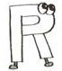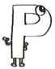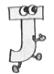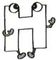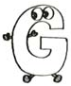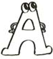
( ) ( ) ( ) ( ) ( ) ( )
二、听音，选出录音所读句子中所含有的单词或字母。（10分）
( ) 1. A. orange B. oranges C. hello
( ) 2. A. some B. come C. home
( ) 3. A. chair B. pear C. bear
( ) 4. A. fruit B. four C. for
( ) 5. A. egg B. elephant C. seven
( ) 6. A. BEG B. DEP C. DPG
( ) 7. A. JFQ B. JEQ C. IEC
( ) 8. A. dbp B. bdq C. dqp
( ) 9. A. gmn B. jmn C. jnm
( ) 10.A. sure B. really C. thanks
三、听音，给下列句子标序号。（6分）
( ) OK，mum!
( ) Let's buy some fruit.
( ) Yes, I like them very much.
( ) Do you like pears?
四、听问句，选择正确的答语。（8分）
( )1. A. Yes, I don't. B. No, I do. C. Yes, I do.
( )2. A. She's my sister. B. She's my mother. C. He's my brother.
( )3. A. Sorry, I don't like. B. No, thanks. C. Here you are.
( )4. A. It's a watermelon. B. It's an apple. C. It's an orange.

笔试部分 （70分）
一、写出下列字母的左邻右舍，注意大小写。（8分） 例子: A B C a b c
1. J 2. P

3. ɡ 4. r
二、看图，写出下列单词中所缺的字母。（6分）
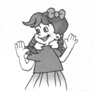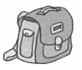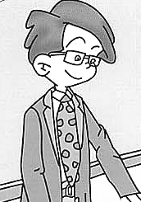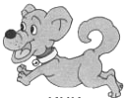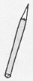
g l ag t cher d g encil j ce
三、看图，把下列各种水果的序号填在( )内。（5分）
A. pear B. apple C. grapes D. bananas E. peach(桃子)
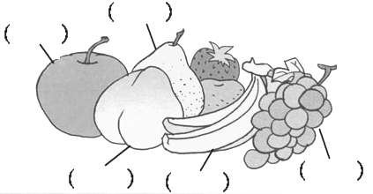
四、写出下列单词的复试形式。（5分）
book ( ) leg ( ) milk ( )
strawberry ( ) bread（ ）
五、找出划线部分发音不同的单词，将序号填在题前的括号内。（5分）
（ ）1、 A apple B bag C cat D car
（ ）2、 A leg B green C desk D elephant
（ ）3、 A like B big C milk D six
（ ）4、 A box B dog C today D orange
（ ）5、 A under B buy C duck D run
六、根据<A>栏中的问句，在<B>栏中选出正确答语。（5分）
<A> <B>
( )1. Have some fruit. A. Yes, I do.
( )2. Can I have an apple? B. OK, mum.
( )3. Do you like pears? C. Here you are.
( )4. I don't like oranges. D. Thank you.
( )5. Let's buy some apples. E. Me, neither.
七、看图，选出与图意相符的句子或对话，将序号填在( )内。（5分）
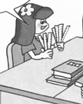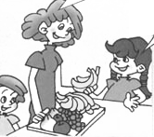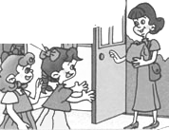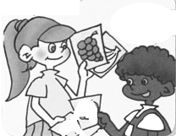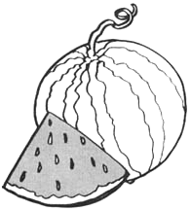
( ) ( ) ( ) ( ) ( )
1. I like watermelons. 2. I have seven rulers.
3. –What's this? - It's grape.
4 .–Who's that woman? –She's my mother.
5. - Do you like bananas, Chen Jie? - Sorry, I don't like bananas.
八、照样子，把下列单词连成一个通顺的句子，将序号填在横线上。（6分）
例子① you ② Do ③ pears ④ like (?) ② ① ④ ③ ?
1. ① some ② fruits ③ Have (.)
2. ① are ② you ③ from ④ Where (?)
3. ① This ② my ③ mum ④ is (.)
九、找出下列各组中不同类的单词，将序号填写在前面的括号内。（5分）
（ ）1、 A apple B banana C pear D milk
（ ）2、 A blue B grape C brown D green
（ ）3、 A seven B nine C see D eight
（ ）4、 A pencil B pear C ruler D eraser
（ ）5、 A boat B bird C panda D tiger
十、选择恰当的单词填空，把序号填在提前括号内。（10分）
（ ）1、_____ apple a day． Ａ．A B．An
（ ）2、_______you like pears? A. Can B. Do
（ ）3、Me______ . A. too B. to
（ ）4、Have some______ A. grape B. grapes
（ ）5、I'm_______ China. A. to B. from
（ ）6、Yes, I ______. A. do B. don’t
（ ）7、Have some fruit.---____________
A. Here you are. B. Thank you.
（ ）8、Do you like grapes? . ---____________
A. Yes, it is. B. No, I don't.
（ ）9、What fruit do you like? . ---____________
A. I like red. B. I like oranges.
（ ）10、Have some ____________.
A. strawberry B. strawberries
十一、根据问句，选择合适的答语并将其序号填在题前括号内。（5分）
（ ）Can I have a pear? A. No, I don't.
（ ）Do you like grapes ？ B. 11.
（ ）Have some juice, please. C. Ok!
（ ）How many bananas ? D. Here you are.
（ ）Let's go home. E. Thank you .
十二、阅读短文，判断正误，正确的写“T”，错误的写“F”（5分）
Hello! I am Wang Hong. I like apples very much. I don't like grapes. My father likes watermelons. He doesn't like strawberries. My mother likes bananas. She doesn't like pears.
( ) 1. Wang Hong likes apples.
( ) 2. Wang Hong doesn’t like pears.
( ) 3. Her(她的) father likes watermelons.
( ) 4. Her mother likes bananas.
( ) 5. Her mother doesn’t like oranges.

PEP小学英语三年级下册单元测试题
听力材料及答案
Unit 5 Do You Like Pears?
Listening content:
一、听音，按录音所读的顺序，给下列字母标号。
1. Show me the letter J. 2. Show me the letter G.
3. Show me the letter A. 4. Show me the letter P.
5. Show me the letter R. 6. Show me the letter H.
二、听音，选出录音所读句子中所含有的单词或字母。
1. Do you like oranges? 2. Have some more?
3. I have a Teddy Bear. 4. This is for you.
5. -How many peaches? -Seven.6. Show me the big letter DEP.
7. Show me the big letter JFQ.8. Show me the small letter dbp.
9. Show me the small letter jmn.10.-My mom is an actress? -Really?.
三、听音，用大写字母给下列句子标号。
1 Let's buy some fruit. 2 OK，mum!
3 Do you like pears? 4 Yes, I like them very much.
四、听问句，选择正确的答语。
1. Do you like oranges? 2. Who's this girl?
3. Can I have an apple? 4. It’s green and red， What’s this?

